**HORMISDALLEN SCHOOL - KYEBANDO**

PRE- PLE SET 11 EXAMINATIONS, 2023

PRIMARY SEVEN SCIENCE

Duration: 2 Hours 15 Minutes

NAME: ______________________________________________ STREAM: _________

INDEX NO.

EMIS NO.

**SECTION A**

1. Name any one group of organisms involved in soil formation.

____________________________________________________________________

2. How can parents protect their children against kwashiorkor?

____________________________________________________________________

3. What is the importance of a shade on a nursery bed?

____________________________________________________________________

4. State one way in which plants depend on animals in the environment.

____________________________________________________________________

5. Of what function are flowers to a plant?

____________________________________________________________________

6. Write any one principle of Primary Health Care.

____________________________________________________________________

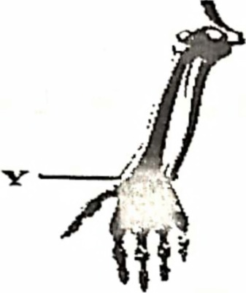*The diagram below shows part of the human skeleton. Study it and answer questions* 7 *and 8.*

7. Name the movable joint located at the point labeled Y.

____________________________________________________________________

8. Identify any one injury that can occur at point Y.

____________________________________________________________________

9. State one characteristic of seeds dispersed by water.

____________________________________________________________________

10. Give any one condition that can make man vulnerable .

____________________________________________________________________

11. How does the practice of keeping fish in a pond at home control malaria?

____________________________________________________________________

12. Mention one natural method of birth control.

____________________________________________________________________

13. How does sun drying help to preserve harvested crops?

____________________________________________________________________

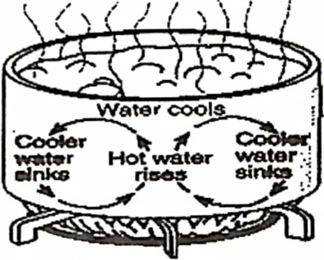***Below is* a *method of heat transfer. Use it to answer the questions 14 and 15.***

14. By what process does heat travel through the boiling water?

____________________________________________________________________

15. What do the arrows in the water represent?

____________________________________________________________________

16. Give one function of blood plasma.

____________________________________________________________________

17. Identify any one disorder of the human teeth.

____________________________________________________________________

18. State one way in which plants are used as energy resources.

____________________________________________________________________

19. Mention any one example of a chemical change that requires oxygen

to occur .

____________________________________________________________________

20. What is the main duty of the drone bee in the colony?

____________________________________________________________________

21. Write one characteristic of arthropods.

____________________________________________________________________

22. In which way are plant leaves adapted to making food?

____________________________________________________________________

23. Form a correct food chain using the organisms.

Squirrel, groundnuts, bacteria, python .

____________________________________________________________________

24. What do we call the frequent passing out of watery stool with blood stains?

____________________________________________________________________

25. Name the type of root system drawn below .

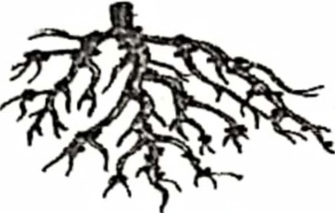

___________________________________________

31. State the energy change that takes place in a bicycle dynamo.

____________________________________________________________________

32. Give any one characteristic of enzymes.

____________________________________________________________________

33. Write one method of applying fertilizers in the garden.

____________________________________________________________________

34. How are birds able to cover viscosity friction during flight?

____________________________________________________________________

The diagram below shows a method of propagation. Study it and answer the question that follows.

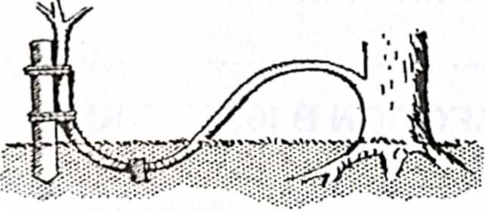

35. Name the method of plant propagation shown in the diagram above.

____________________________________________________________________

36. In which body organ does filtration of blood take place?

____________________________________________________________________

37. State one effect of smoking to a pregnant woman.

____________________________________________________________________

38. Name the fungus that normally develops on the leftover foods.

____________________________________________________________________

39. How is a kink of a clinical thermometer similar to the valves of the human heart?

____________________________________________________________________

40. A vacuum flask is an important device in a home. Why is it not common in rural homes?

____________________________________________________________________

**SECTION B**

41. a) Which tissue joins muscles to bones at the joint?

____________________________________________________________________

b) Mention any two examples of involuntary muscles

(i) ____________________________________________________________________

(ii) ____________________________________________________________________

c) State any one function of the human skeleton.

____________________________________________________________________

42. a) Give any one cause of accidents at home.

____________________________________________________________________

b) Identify the type of accident which involves the following first

aid activities;

i) applying clean cold water on the injured part.

____________________________________________________________________

ii) typing splints around the injured part.

____________________________________________________________________

c} Why should milk be given to a person who has taken rat poison?

____________________________________________________________________

43. Below is a diagram of a simple machine. Study it and answer the questions that follow.

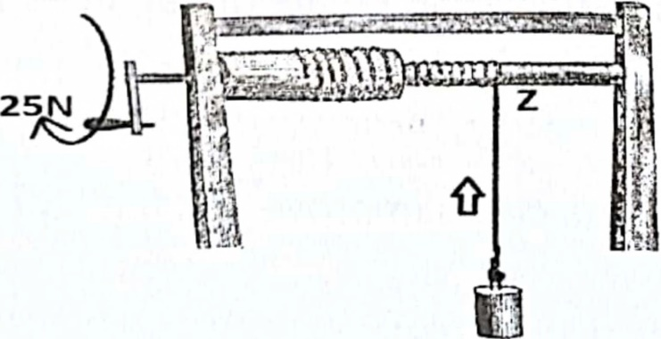

**100N**

a) To which group of simple machines does the machine belong?

____________________________________________________________________

b} Name the part of the machine labeled Z.

____________________________________________________________________

(c) Use letter E to indicate the position of the effort on the machine.

(d) Calculate the mechanical advantage of the above machine.

44. (a) Mention one example of a leguminous crop.

____________________________________________________________________

b) State one characteristic of leguminous crops.

____________________________________________________________________

c) To which group of flowering plants do legumes belong?

____________________________________________________________________

d) How do leguminous crops improve soil fertility?

____________________________________________________________________

45. a) State any two indicators of poor sanitation in a home.

____________________________________________________________________

b) Mention two dangers of poor sanitation in a home.

(i) ____________________________________________________________________

(ii) ____________________________________________________________________

46. a) Mention two methods of preparing food to make it ready for eating.

(i) ____________________________________________________________________

(ii) ____________________________________________________________________

(b) What is the importance of cooking meat before eating it?

______________________________________________________________________

c) Why do most people cover food during the process of cooking?

____________________________________________________________________

47. a) State the law of magnets.

____________________________________________________________________

b) Give any two uses of magnets in our daily life.

(i) ____________________________________________________________________

(ii) ____________________________________________________________________

c) Identify any one way in which magnets lose magnetism .

____________________________________________________________________

48. The diagram below shows a routine practice done on a certain cattle farm. Use it to answer the questions that follow.

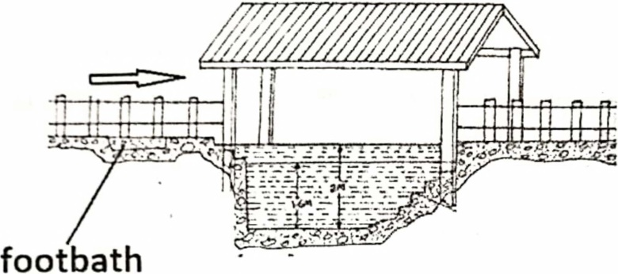

a) Name the routine practice shown in the diagram above.

____________________________________________________________________

b) How important is the above practice on a cattle farm?

____________________________________________________________________

c) Give the importance of a foot bath on the above structure.

____________________________________________________________________

d) State one cattle pest that can be controlled using the above practice?

____________________________________________________________________

49. a) Mention any two examples of tuber crops.

(i) ____________________________________________________________________

(ii) ____________________________________________________________________

b) Write one method used to harvest tuber crops.

____________________________________________________________________

c) Give any one method of controlling pests in tuber crops .

____________________________________________________________________

50 Match the items in list A to their meaning in list

|  |  |
| --- | --- |
| LIST A | LIST B |
| 1. Capacity 2. Volume 3. Mass 4. Weight | * The space occupied by an object * The amount of matter in an object * Gravitational force acting on an object * Amount of liquid a container holds * How light or heavy an object is |

1. Capacity ______________________________________
2. Volume_________________________________________
3. Mass _________________________________________
4. Weight ________________________________________

51. a) Give two waste products removed from the body by the lungs.

(i) ____________________________________________________________________

(ii) ____________________________________________________________________

b) Why are lungs grouped under excretory organs?

____________________________________________________________________

c) Mention one anti-social behavior that damages the lungs.

____________________________________________________________________

52. a) Write one type of poultry reared in Uganda.

____________________________________________________________________

(b) Why is poultry keeping called a business?

____________________________________________________________________

____________________________________________________________________

(c) State one cause of poultry vices.

____________________________________________________________________

(d) Give any one way farmers control vices on their poultry farms.

____________________________________________________________________

53. The diagram below shows a type of tooth. Use it to answer questions that follow.

 

1. ldentify the type of tooth drawn above.

____________________________________________________________________

(b)Name the regions of the tooth labeled

K ____________________________________________________________________

L ____________________________________________________________________

(c)How is the above tooth adapted to its function?

____________________________________________________________________

54. (a) Which type of immunity is got through immunization?

____________________________________________________________________

b) Give one method used to administer vaccines to babies.

____________________________________________________________________

c) How is a child health card useful to the;

(i) mother __________________________________________________________

_______________________________________________________________

(ii) nurse ___________________________________________________________

_______________________________________________________________

55. a) State two characteristics of images formed by plane mirrors.

i) ___________________________________________________________________

ii) __________________________________________________________________

b) Why are plane mirrors called optical instruments?

____________________________________________________________________

c) State any one use of plane mirrors in our daily life

_____________________________________________________________________

**END**